1. Which are the top three variables in your model which contribute most towards the probability of a lead getting converted?

Solution:

According to the coefficients of our model, below are the top three variables which contribute most towards probability:

1.Lead Add form (from lead Origin)

2. Working Professional (from What is your current occupation)

3. Unreachable ( from Last Notable Activity)

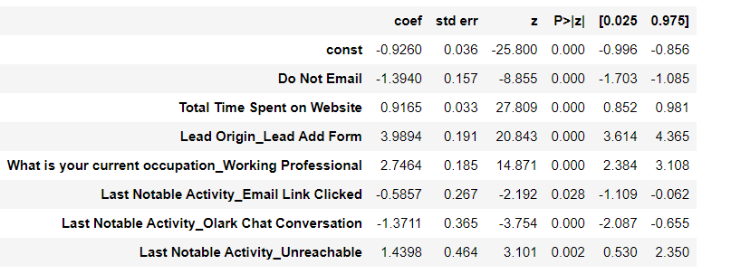

1. What are the top 3 categorical/dummy variables in the model which should be focused the most on in order to increase the probability of lead conversion?

Solution:

Again based on the same coefficient values we would be able to answer, the top 3

variables categorical/dummy variables in the model which contribute most towards probability:

1.Lead Add form (from lead Origin)

2. Working Professional (from What is your current occupation)

3. Unreachable ( from Last Notable Activity)

1. X Education has a period of 2 months every year during which they hire some interns. The sales team, in particular, has around 10 interns allotted to them. So during this phase, they wish to make the lead conversion more aggressive. So they want almost all of the potential leads (i.e. the customers who have been predicted as 1 by the model) to be converted and hence, want to make phone calls to as much of such people as possible. Suggest a good strategy they should employ at this stage.

Solution:

In order to increase the conversion of potential leads to be successful. The interns should contact all the leads for whom the probability value >0.3

Even though you will get more accuracy for probability value of 0.4 it’s best to concentrate on all leads for whom probability value starts from 0.3

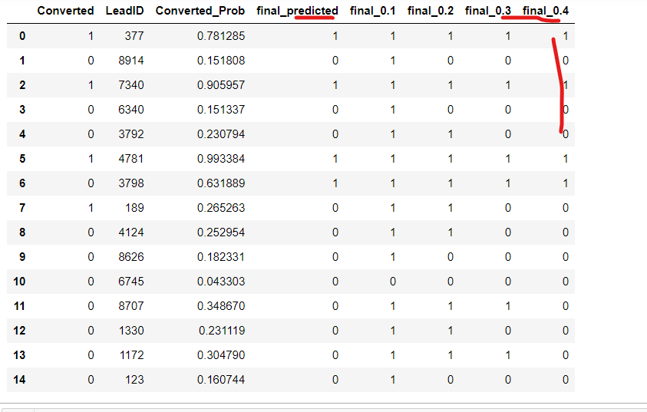

1. Similarly, at times, the company reaches its target for a quarter before the deadline. During this time, the company wants the sales team to focus on some new work as well. So during this time, the company’s aim is to not make phone calls unless it’s extremely necessary, i.e. they want to minimize the rate of useless phone calls. Suggest a strategy they should employ at this stage.

Solution:

In order to avoid the unwanted calls unless it’s extremely necessary, the company can focus on the people for whom the probability value is up and above 0.7. Even though it will not promise a good conversion rate. Ex: in the image for lead id 189 you might not be able to convert the lead if you are following that purpose.

